NAME : Utsa Maiti

YEAE:3rd Year

SEMESTER : V

SECTION: A

REGISTRATION NO.: AU/2022/0007579

ROLL NO.: UG/02/BTCSE/2022/053

SUBJECT: Introduction to Python

Assignment

Date of Submission: 23/09/2024

**(Q.1.) Perform a Fast Fourier Transform (FFT) on a sine wave signal and visualize both the original signal and its frequency spectrum.**

**Ans.** To execute this:-

**Source Code:-**

import numpy as np

import matplotlib.pyplot as plt

sampling_rate=1000

frequency=5

amplitude=1

time=1

t=np.linspace(0, duration, sampling_rate*time)

SineWave=amplitude*np.sin(2*np.pi*frequency*t)

magnitude_fft=np.abs(np.fft.fft(sine_wave))

frequency_fft=np.fft.fftfreq(len(magnitude_fft), 1/sampling_rate)

plt.figure(figsize=(12, 6))

plt.subplot(2, 1, 1)

plt.plot(t, sine_wave, color='pink')

plt.title('Original Sine Wave')

plt.xlabel('Time [s]')

plt.ylabel('Amplitude')

plt.grid()

plt.subplot(2, 1, 2)

plt.plot(frequency_fft[:len(frequency_fft)//2], magnitude_fft[:len(magnitude_fft)//2], color='green')

plt.title('Frequency Spectrum')

plt.xlabel('Frequency [Hz]')

plt.ylabel('Magnitude')

plt.grid()

plt.tight_layout()

plt.show()

**Output:-**

The code is executed

**Code Snippet:-**

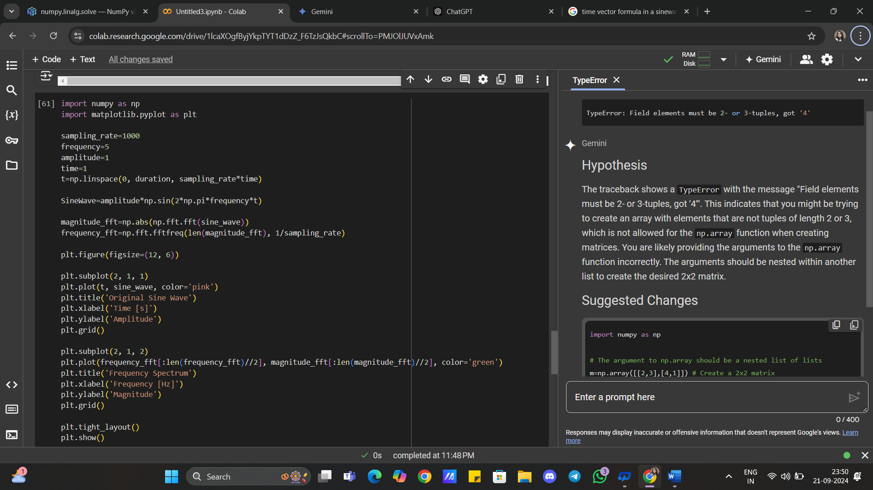

**Output:-**

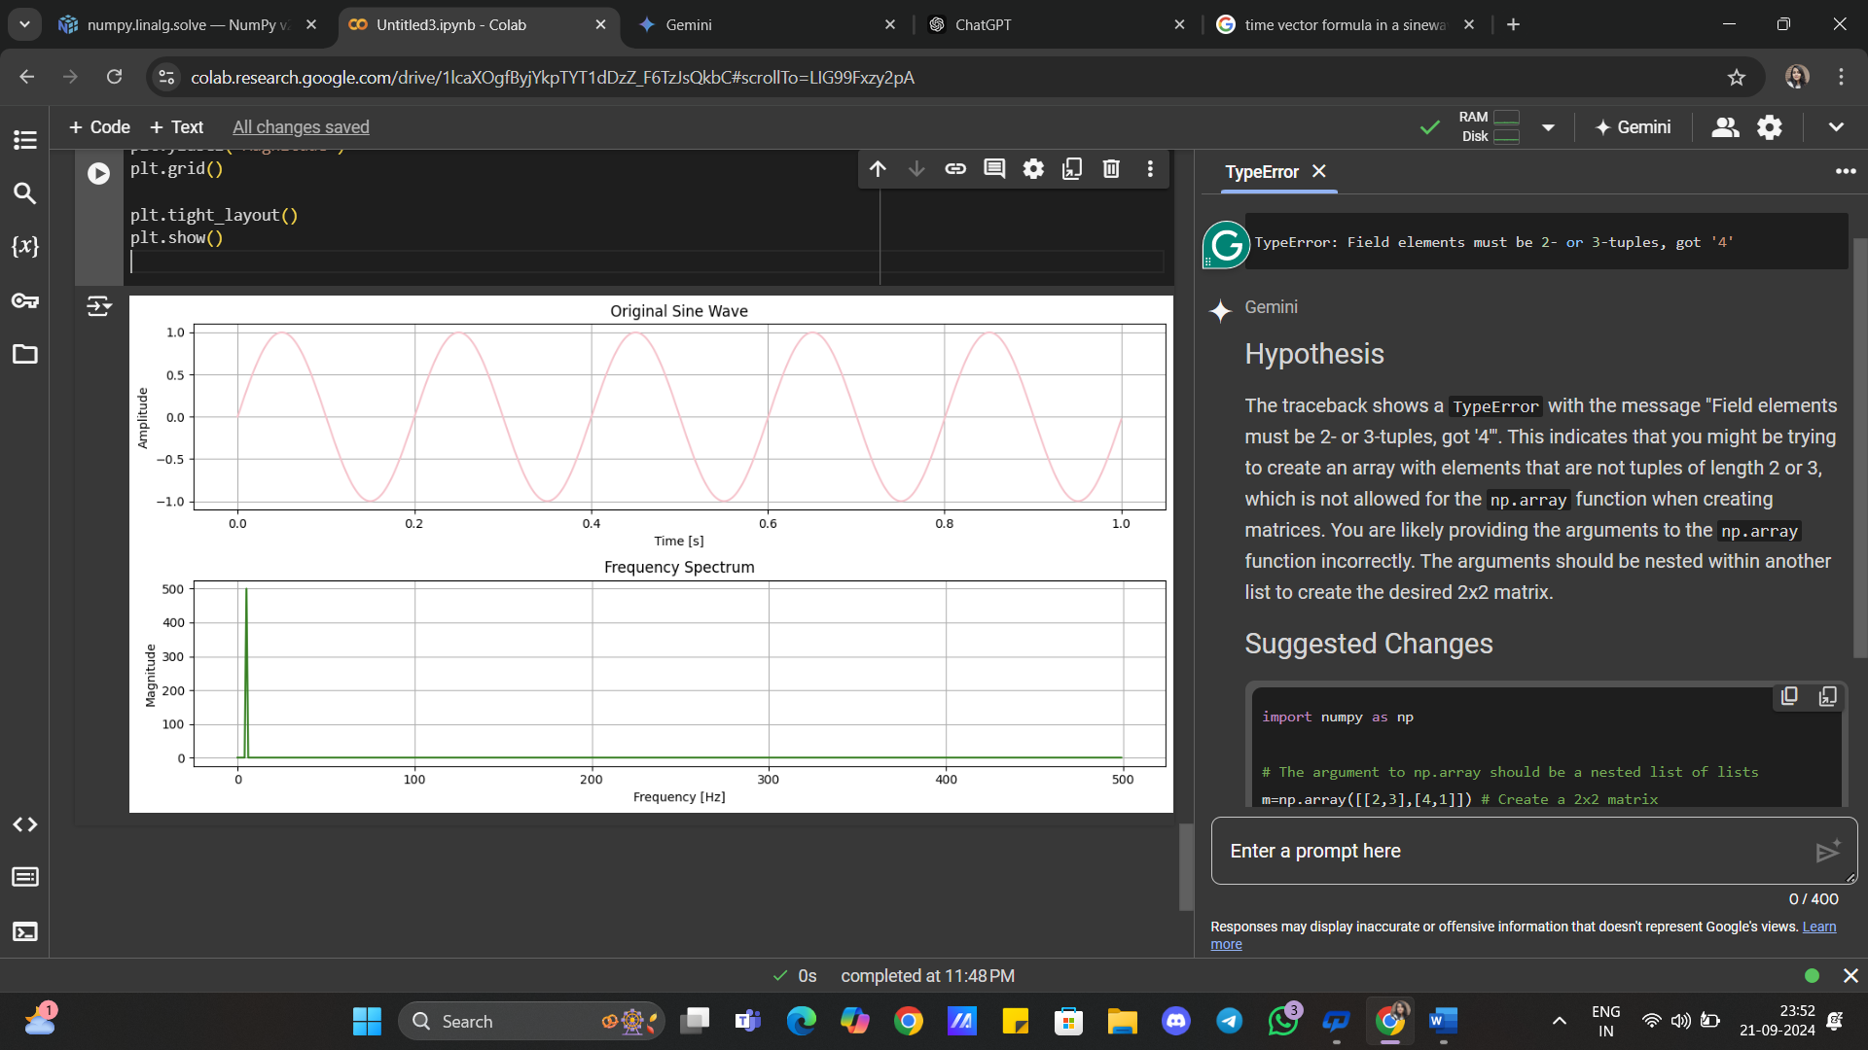

**(Q.2.)Using scipy in python integrate a function f(x)=x^2 in range [0,5]from scipy import integrate**

**Ans.** To execute this:-

**Source Code:-**

def f(x):

  return x**2

result,error=integrate.quad(f,0,5)

print("The Integration value is : ",result)

print("The Error value is : ",error)

**Output:-**

The Integration value is : 41.66666666666666

The Error value is : 4.625929269271485e-13

**Code Snippet:-**

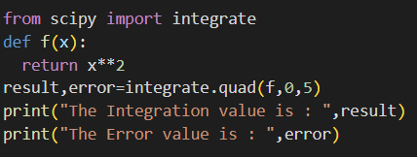

**Output:-**



**(Q.3.)** **Solve a simple optimization problem where you need to minimize the function f(x)=(x-3)²+2 using scipy.optimize**

**Ans.** To execute this:-

**Source Code:-**

 import numpy as np

 from scipy.optimize import minimize

 def f(x):

  return (x-3)**2+2

result=minimize(f,0)

print("The Optimized value is : ",result.fun)

print("The value of x which optimizes the function is:", result.x)

**Output:-**

The Optimized value is : 2.000000000000001

The value of x which optimizes the function is: [3.00000003]

**Code Snippet:-**

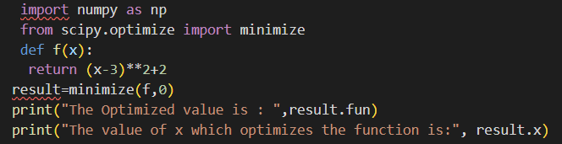

**Output:-**



**(Q.4.)** **Solve a system of linear equations using numpy. Given the system**

**2x+3y=5**

**4x+y=6**

**Solve for x and y**

**Ans.** To execute this:-

**Source Code:-**

import numpy as np

m=np.array([[2,3],[4,1]])

n=np.array([5,6])

result=np.linalg.solve(m,n)

print(“The solution of the system of equations : “,result)

**Output:-**

The Integration value is : 41.66666666666666

The Error value is : 4.625929269271485e-13

**Code Snippet:-**

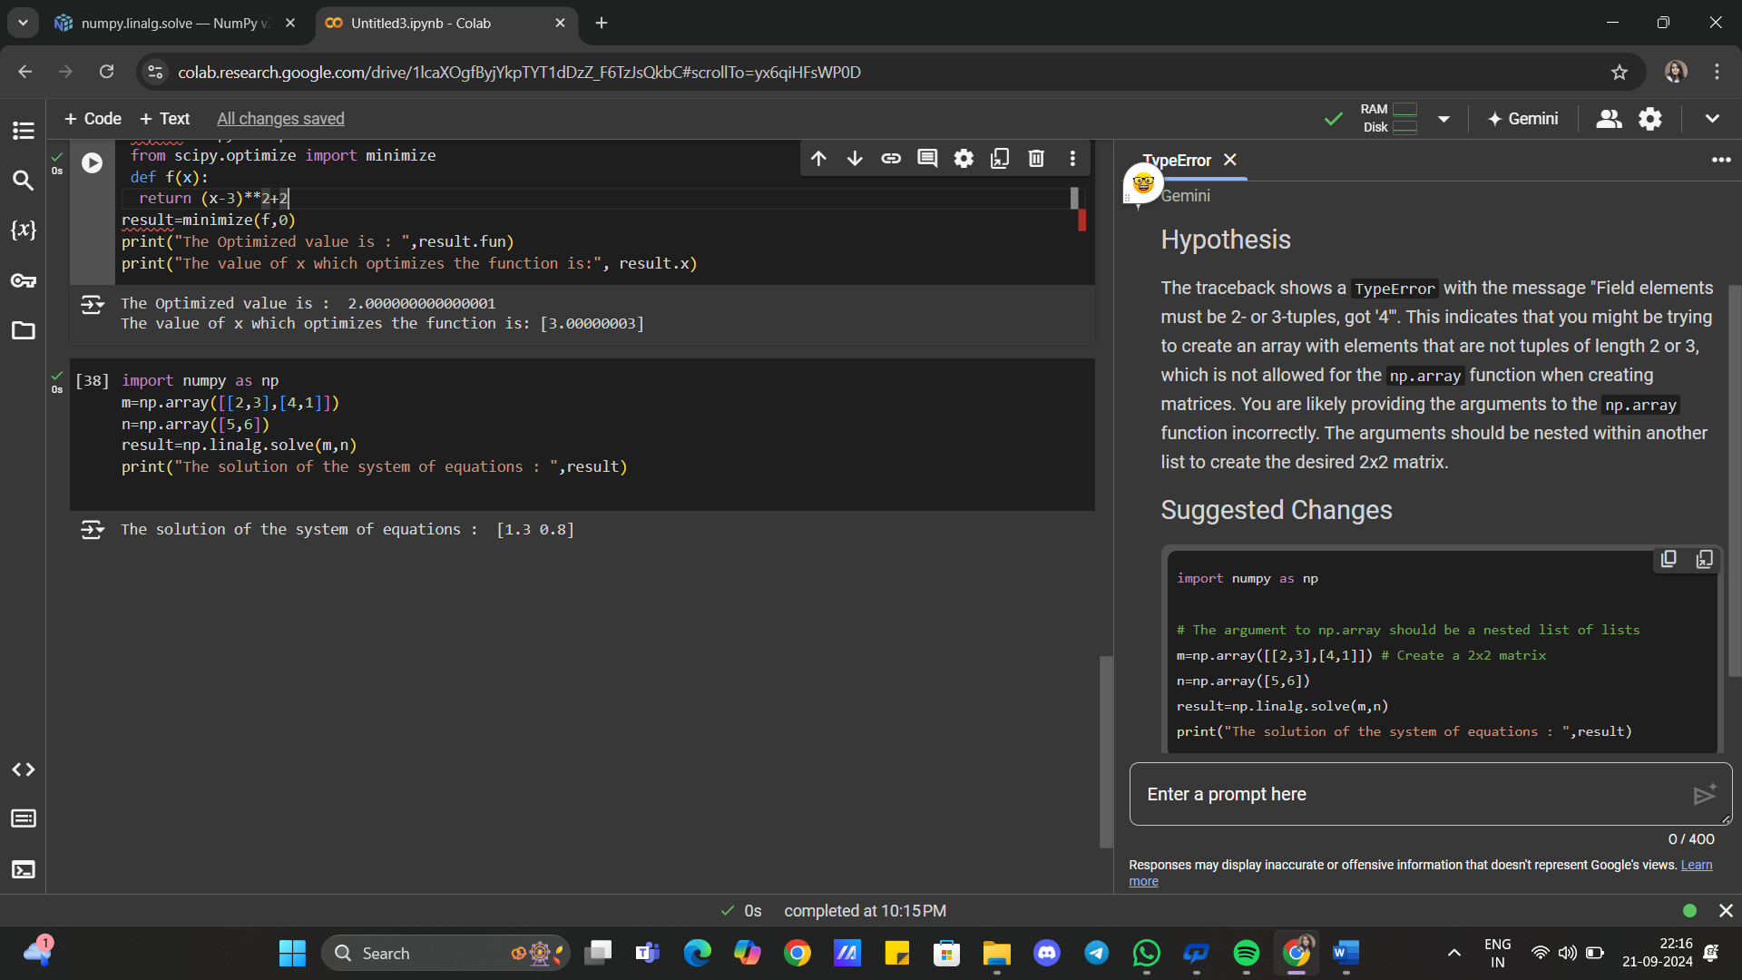

**Output:-**

